ICT-3200, Industrial Visit Report, Part-3
Power Transmission Substation Sylhet

Department of Information and Communication Technology

Mawlana Bhashani Science and Technology University

Contents

- Student Information 2
- Introduction 2
- Objectives 2
- Overview of the Transmission Station 2
- Major Components Observed 3
- Power Transmission Process 4
- Protection Systems 4
- Supervisory Control and Data Acquisition and Automation 4
- Communication Systems 4
- ICT Applications 5
- Safety Procedures 5
- Learning Outcomes 6
- Recommendations 6
- Conclusion 6

Appendix

Student Information
Name: Kuldip Saha Mugdha
Student ID: IT22018
Session: 2021-22
Semester: 3rd year, 2nd semester
Date of Visit: 22 July,2026
Submission Date: 3 August,2026

Introduction
The purpose of this industrial visit was to observe the operation and management of the Power Transmission Sub-Station, Sylhet, which plays a vital role in Bangladesh's national electricity transmission network. The visit provided practical knowledge about high-voltage power transmission, electrical equipment, protection systems, automation technologies, and ICT applications used in modern substations. It helped bridge the gap between theoretical concepts learned in the classroom and real-world industrial practices.

Objectives
The objectives of this industrial visit were:
- To understand the structure of Bangladesh's power transmission network.
- To observe the operation of high-voltage transmission equipment.
- To learn about modern protection systems used in substations.
- To understand the implementation of SCADA for remote monitoring and control.
- To study communication technologies used in power transmission.
- To observe safety measures followed inside a transmission substation.
- To understand the importance of ICT in smart power systems.

Overview of the Transmission Station
The Power Transmission Sub-Station, Sylhet is operated by Power Grid Bangladesh PLC (PGCB), the organization responsible for transmitting electricity throughout Bangladesh. The station is an important part of the national grid and ensures reliable electricity supply to Sylhet and the surrounding regions.
The substation operates at high-voltage levels (typically 132 kV and 230 kV) to minimize transmission losses over long distances. It receives electricity from generating stations through transmission lines and delivers power to distribution substations after voltage transformation.
Because of its strategic location, the Sylhet Transmission Sub-Station significantly contributes to maintaining power system stability and uninterrupted electricity supply in the northeastern region of Bangladesh.

Major Components Observed
During the visit, the following equipment and components were observed:
1. Power Transformers:
Power transformers increase or decrease voltage levels for efficient power transmission while minimizing energy loss.
2. Busbars:
Busbars collect electrical power from different incoming transmission lines and distribute it to outgoing feeders.
3. Circuit Breakers:
Circuit breakers automatically disconnect faulty sections of the power system during abnormal conditions.
4. Isolators:
Isolators provide safe isolation of electrical equipment during maintenance operations.
5. Current Transformers (CT):
CTs reduce high transmission current into measurable values for protection relays and metering.
6. Potential Transformers (PT/CVT):
These transformers convert high voltage into standard low-voltage values suitable for measuring instruments.
7. Lightning Arresters:
Lightning arresters protect equipment from lightning strikes and switching surges.
8. Capacitor Banks:
Capacitor banks improve power factor, reduce reactive power, and increase transmission efficiency.
9. Control Building:
The control building contains SCADA systems, control panels, communication equipment, and protection relays.
10. Protection Panels:
Protection panels continuously monitor system conditions and operate protective relays whenever faults occur.

Power Transmission Process
The power transmission process observed during the visit consists of the following stages:
- Electricity is generated at power plants.
- The voltage is stepped up using power transformers.
- High-voltage electricity is transmitted over long distances through transmission lines.
- At the transmission substation, the voltage is transformed to suitable levels.
- Electricity is then supplied to local distribution substations.
- Finally, power reaches residential, commercial, and industrial consumers through the distribution network.
This process minimizes transmission losses and ensures reliable power delivery.

Protection Systems
The substation employs several advanced protection schemes, including:
- Distance Protection
- Differential Protection
- Over current Protection
- Earth Fault Protection
- Relay Coordination
- Automatic Circuit Breaker Operation
These systems continuously monitor electrical parameters and isolate faulty sections immediately to prevent equipment damage and maintain system reliability.

Supervisory Control and Data Acquisition (SCADA) and Automation
The Sylhet Transmission Sub-Station uses SCADA technology for centralized monitoring and control.The SCADA system includes:
- Remote Terminal Units (RTUs)
- Human Machine Interface (HMI)
- Supervisory Control
- Real-time Monitoring
- Alarm Management
- Event Logging
Operators can monitor equipment status, voltage, current, breaker positions, and fault conditions from the control room, improving operational efficiency and reducing response time.

Communication Systems
Reliable communication is essential for modern substations.
The communication technologies observed include:
- Optical Fiber Communication
- Optical Ground Wire (OPGW)
- MPLS/IP Network
- IEC 61850 Communication Standard
- IEC 60870-5-104 Protocol
- Tele protection System
- GPS Time Synchronization
These technologies ensure secure, high-speed, and reliable communication among substations and the national control center.

ICT Applications
Modern ICT plays a crucial role in power transmission. The following applications were discussed:
- Industrial Networking
- Cybersecurity
- Smart Grid Technologies
- Data Acquisition Systems
- Asset Management Systems
- Predictive Maintenance
- AI-Based Fault Detection
- Digital Twin Technology
These technologies improve operational efficiency, increase reliability, reduce maintenance costs, and support intelligent power system management.

Safety Procedures
Strict safety measures are followed inside the transmission substation. These include:
- Lock-Out Tag-Out (LOTO) procedures
- Proper Earthing Procedures
- Arc Flash Protection
- Personal Protective Equipment (PPE)
- Restricted Access Zones
- Safety Signboards
- Emergency Response Procedures
All visitors were instructed to follow safety guidelines throughout the visit.

Learning Outcomes
From this industrial visit, we learned:
- The practical operation of Bangladesh's national transmission system.
- Functions of major substation equipment.
- Importance of SCADA in real-time monitoring.
- Role of ICT in modern power transmission.
- Communication technologies used in substations.
- Modern protection techniques.
- Industrial safety procedures.
- Career opportunities in Smart Grid, Power Systems, Automation, and ICT.

Recommendations

Based on our visit, the following recommendations are proposed:

Arrange more industrial visits for ICT students.

Include practical SCADA demonstrations.

Provide hands-on training on power system communication.

Increase awareness of industrial cybersecurity.

Encourage collaboration between universities and PGCB.

Introduce practical workshops on smart grid technologies.

Conclusion

The industrial visit to the Power Transmission Sub-Station, Sylhet was highly informative and educational. It provided valuable practical knowledge about high-voltage power transmission, modern substation equipment, SCADA systems, communication technologies, ICT applications, and industrial safety practices. The visit strengthened our understanding of power system engineering and highlighted the importance of integrating ICT with modern electrical infrastructure. Overall, this experience enhanced our technical knowledge and prepared us for future careers in power systems, automation, and information technology.

Appendix

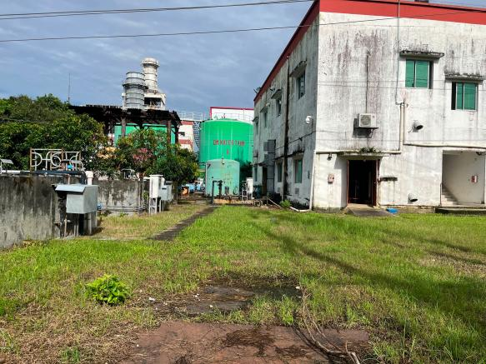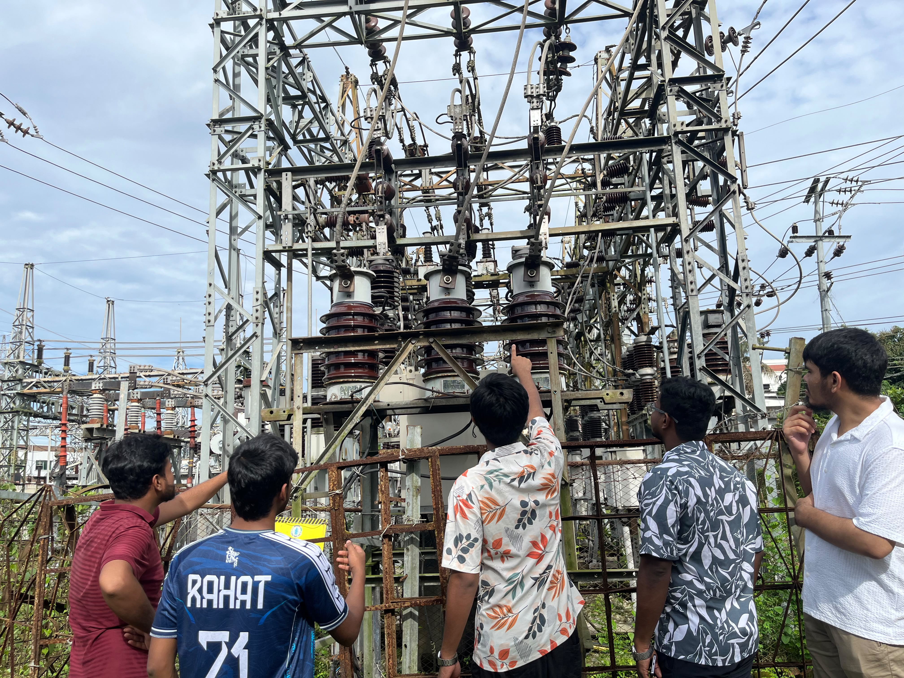
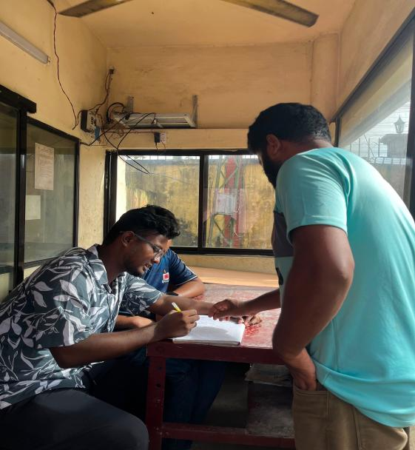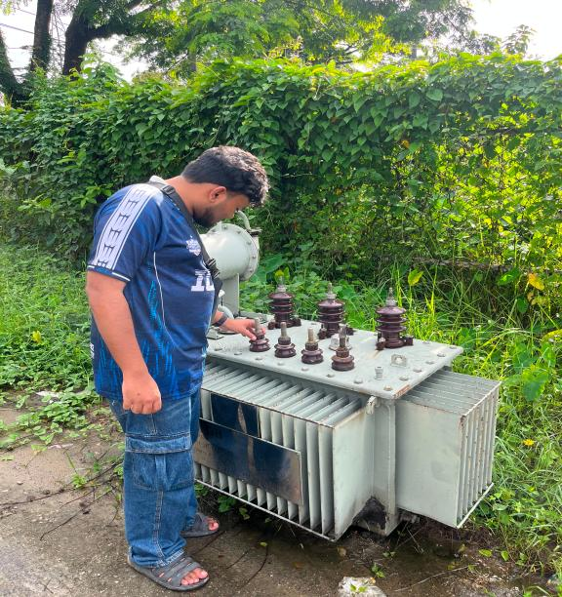
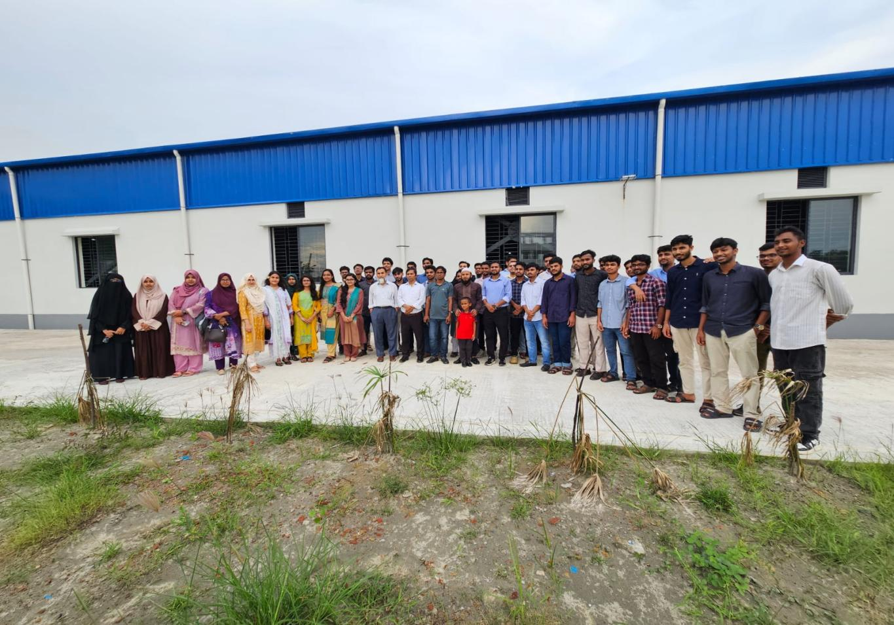

Power Transmission Sub-Station, Sylhet
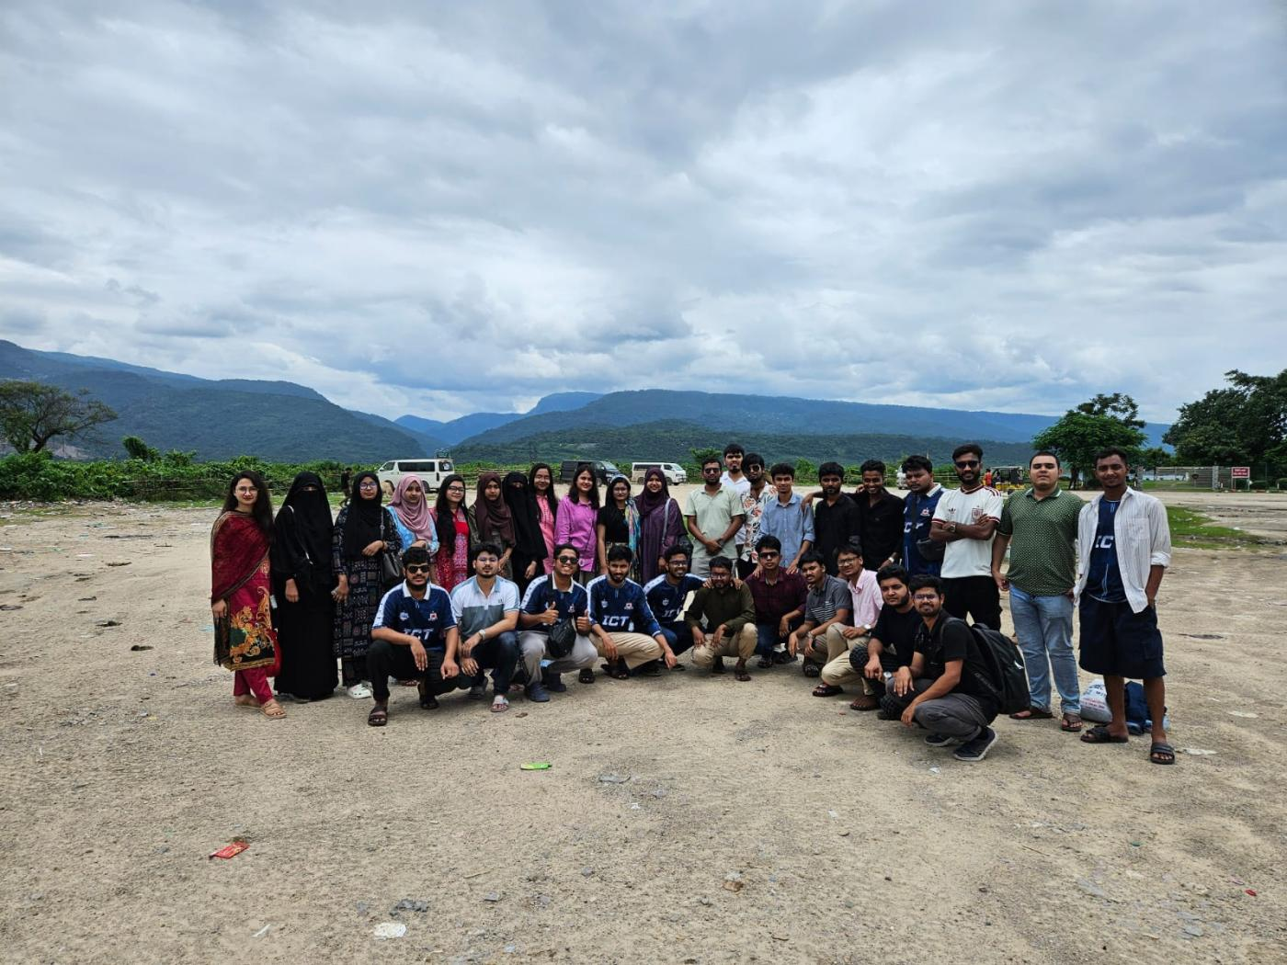

Sada Pathor, Sylhet

